

Guideline for SupplyOn Service Supply WebEDI for Stabilus Suppliers

Delivery Instructions in WebEDI – LIGHT

Version: 2.0

Date: 06.02.2023



Table of Contents

1 Delivery Instructions in Supply Chain Collaboration 3

1.1 Navigating to the Delivery Instructions 3

1.2 Overview 4

1.3 Delivery Instruction Details 6

# Delivery Instructions in Supply Chain Collaboration

Delivery Instructions will be transmitted from your customer to SupplyOn and displayed in the Supply Chain Collaboration afterwards.

In contrast to Orders, they represent a long-term delivery plan for production planning. At the same time, delivery schedules may change over time or become more accurate as the delivery date approaches.

## Navigating to the Delivery Instructions

Enter www.supplyon.com in your browser and click on “Login” and log in with your account credentials.

* Enter your User-ID.
* Enter your password.
* Click the button “Login”.

Go to “SupplyOn Services” and navigate to “Supply Chain Collaboration”.

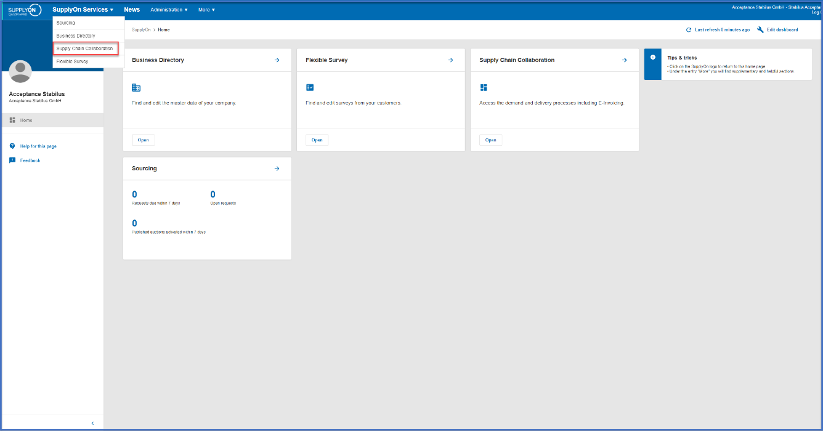

In SupplyOn Supply Chain Collaboration you can see a dashboard with all processes that are activated for your company. Navigate to the card “Delivery Instructions” and click on “Current new Delivery Instructions” or on the blue arrow in the upper right corner.

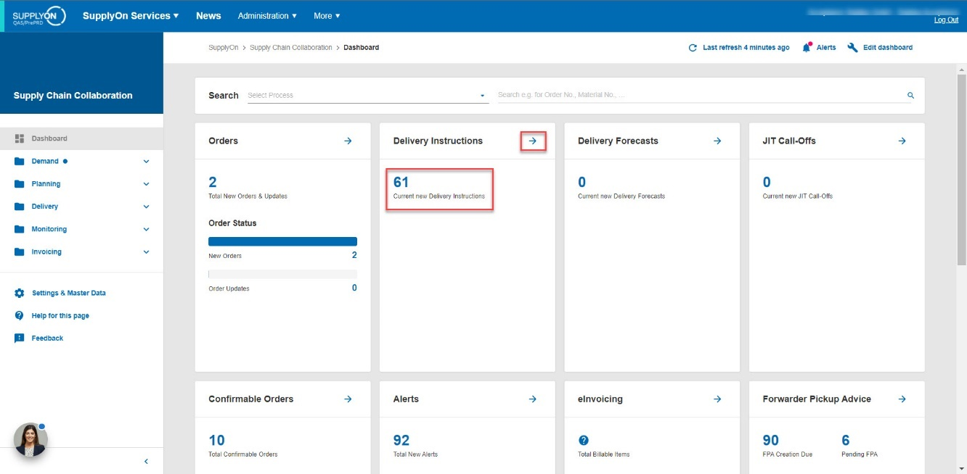

## Overview

After clicking on the right blue arrow, you will get an overview of all delivery instructions.

Information such as customer site, ship-to-address, material, material description, transmission date or status will be displayed and can be filtered.

The Instructions can also be grouped by material number (1) or unloading point (2).

As mentioned before, it is also possible to click on “Current new Delivery Instructions” (1). After doing so, you will get an overview of only those Instructions that are new (2).

The status indicates that these Instructions are new and unread.

After clicking on one of the Instructions, you will see the order details.

## Delivery Instruction Details

“The Delivery Instruction Details” are separated into Material-related information (1), Additional Reference Data (2), Cumulative quantities (3), and the Delivery Instruction Schedule Lines (4).

In the Material-related Information (1) section, you’ll see information such as material, material description, message number, transmission date, validity period and order position.

The additional reference (2) data reveals information about the delivery note number or the current cumulated quantity that has been received so far.

The “Cumulative quantities” area reveals information about incoming and outgoing cumulative quantities. In this example, the customer has received 364.700 pieces so far while the supplier on the other hand has only sent 2000 pieces so far, which doesn’t end up obviously.

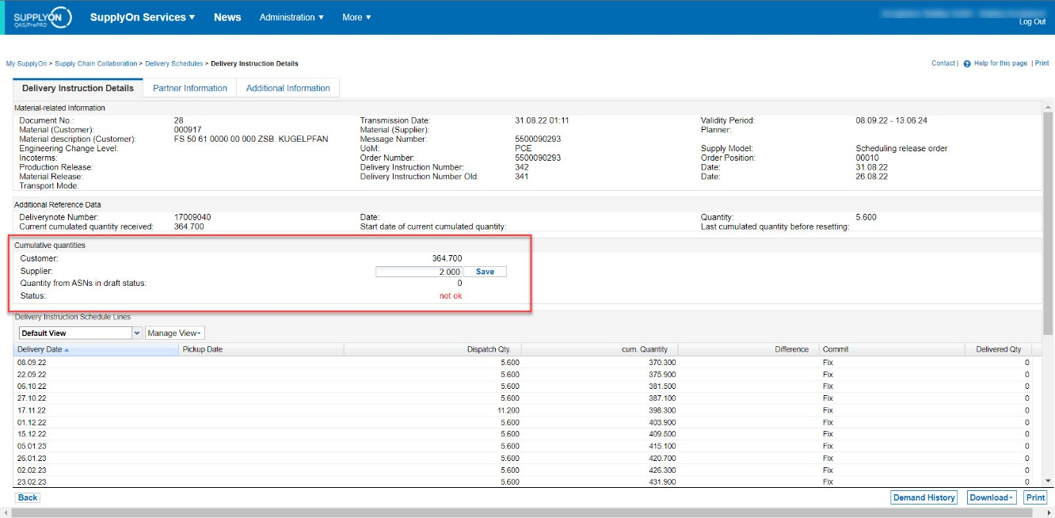

The supplier quantity should at least be congruent to the customer quantity, meaning that the quantity that has been sent out is the quantity that has been received by the customer.

Important step: Please adjust the cumulative quantity field to the already sent quantity in total (before using SupplyOn).

The supplier quantity can also be above the customer quantity, meaning that there are shipments in transit which haven’t arrived at the customer site yet. Furthermore, the status will switch from “not ok” to “ok” if the quantity is congruent or above the customer quantity.

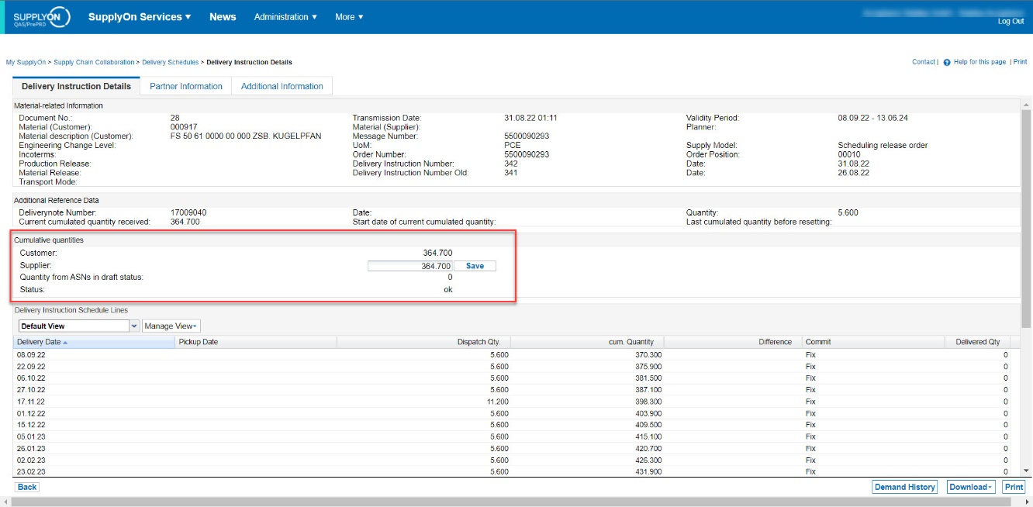

Attention: When working with a new delivery instruction, please make sure that the supplier quantity matches the customer quantity.

The schedule lines contain the specific delivery plan for the required material. Each line contains the delivery date, the dispatch quantity, the cumulative quantity, a possible difference, and the commitment level.

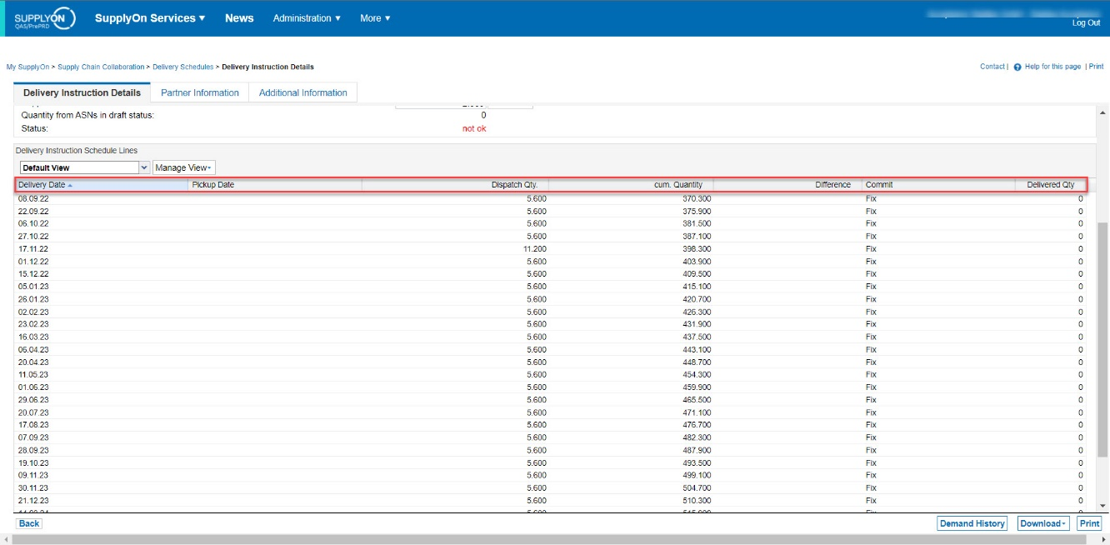

The delivery date is equivalent to the ETA (Estimated Time of Arrival).

Next to the Delivery Instruction Details, the Partner Information reveals details about all involved parties.

In order to indicate that the goods were shipped, please see the guide for ASN Process.